**MODULE 2**

**SECTION 4**

1.Converts given temperature in Fahrenheit to Celsius

**ANSWER:**

public class TemperatureConverter {

public static double fahrenheitToCelsius(double fahrenheit) {

return 5.0 / 9.0 * (fahrenheit - 32);

}

public static void main(String[] args) {

double fahrenheit = 100.0;

double celsius = fahrenheitToCelsius(fahrenheit);

System.out.println("Temperature in Celsius: " + celsius);

}

}

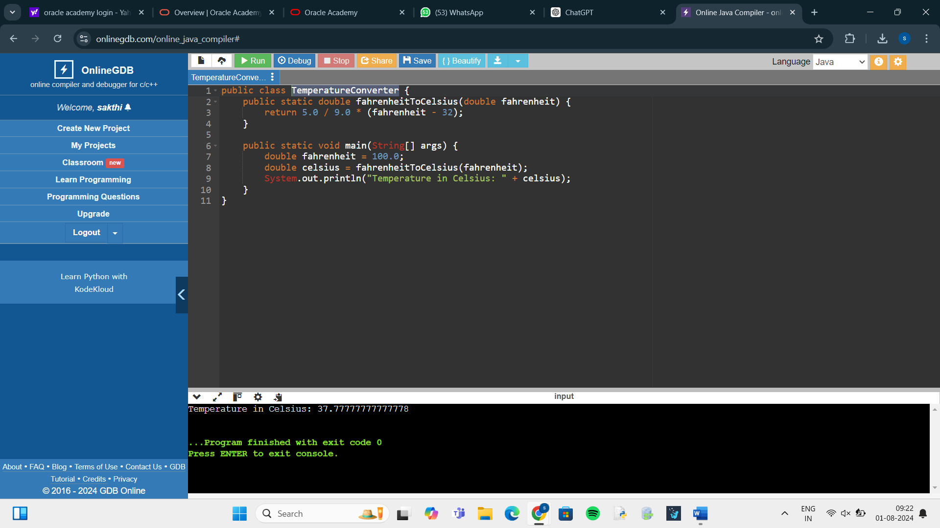

2. Computes the hypotenuse length of a triangle given its side lengths.

**ANSWER:**

import java.util.Scanner;

public class HypotenuseCalculator {

public static void main(String[] args) {

Scanner scanner = new Scanner(System.in);

System.out.println("Enter the length of side a: ");

double a = scanner.nextDouble();

System.out.println("Enter the length of side b: ");

double b = scanner.nextDouble();

double hypotenuse = Math.sqrt(a * a + b * b);

System.out.println("The length of the hypotenuse is: " + hypotenuse);

}

}

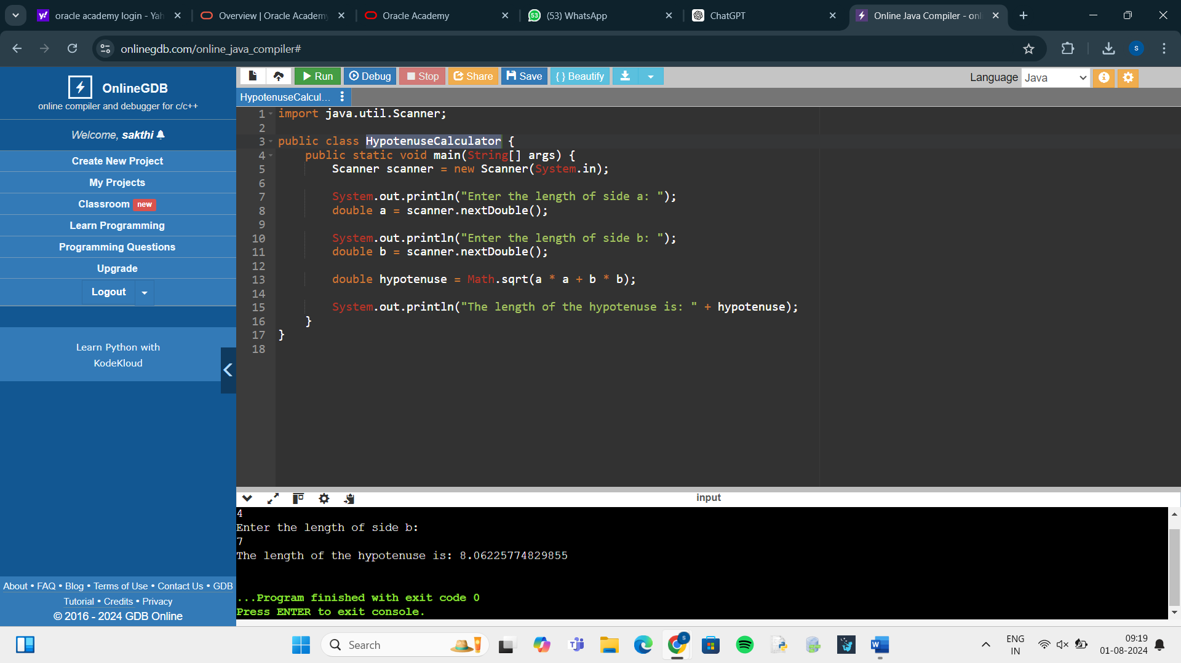

3. Simulate the rolling of two 6-sided dice and display their sum

**ANSWER:**

import java.util.Random;

public class DiceRollSimulation {

public static void main(String[] args) {

Random random = new Random();

int die1 = random.nextInt(6) + 1;

int die2 = random.nextInt(6) + 1;

int sum = die1 + die2;

System.out.println("Roll of die 1: " + die1);

System.out.println("Roll of die 2: " + die2);

System.out.println("Sum of both dice: " + sum);

}

}

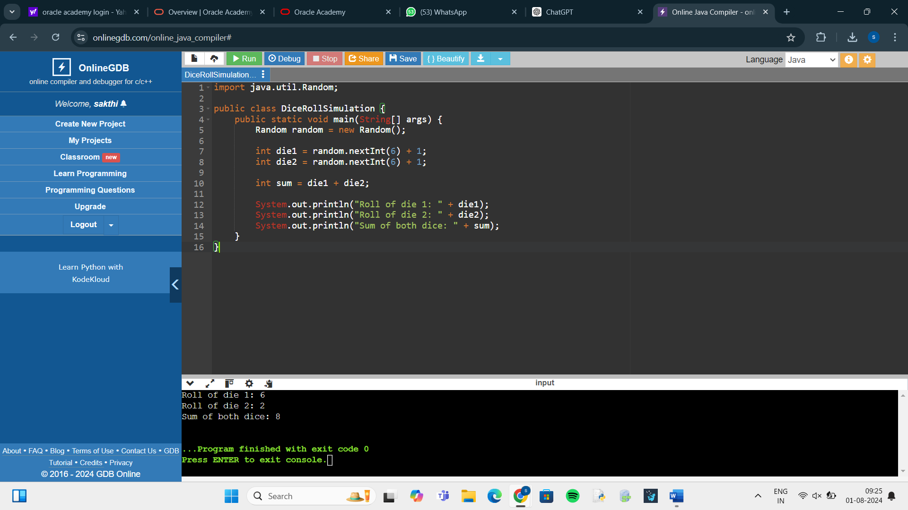

4. In this practice, you will develop a java program that processes a name entered by the user. The program does the following:  
It reads the user's first and last name (read an entire line as a single string), then prints the last name followed by a comma and the first  
initial. (Assume that the user types a valid name.)  
Task  
You must implement the following:  
1. Have the user enter a name  
2. Extract the first and last name from the name entered by the user  
3. Use methods of String class to manipulate name as specified:  
4. Display the name to the console  
Expected Output:  
Type your name: Jenny Weaver  
Your name is: Weaver, J.  
The ProcessName.java file is available to help you get started.

**ANSWER:**

import java.util.Scanner;

public class ProcessName {

public static void main(String[] args) {

// Create a Scanner object to read input from the user

Scanner scanner = new Scanner(System.in);

// Prompt the user to enter their name

System.out.print("Type your name: ");

String fullName = scanner.nextLine();

// Split the full name into first and last name

String[] nameParts = fullName.split(" ");

String firstName = nameParts[0];

String lastName = nameParts[1];

// Get the first initial of the first name

char firstInitial = firstName.charAt(0);

// Print the formatted name

System.out.println("Your name is: " + lastName + ", " + firstInitial + ".");

// Close the scanner

scanner.close();

}

}

